What am I meant to write?

In this substack, I give my reasons for starting this substack. Since it is the first one, it inaugurates this idea of why write, what to write about and what ground rules do I set for myself. Throughout this journey, I do not assure cohesive answers, but I promise an engaging journey. Take it with a pinch of salt!

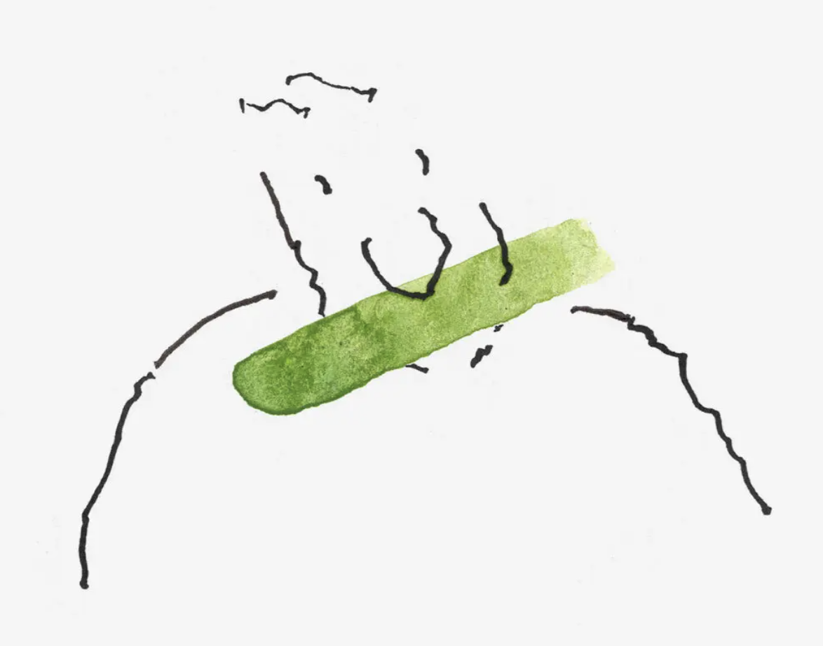

I always wanted to write.

I like the art of expressing stuff going in my mind, which either reflects my life or reflects my thoughts outside of my own immediate occupations. It helps me know what I am thinking and think about what I know.

But I could never do it.[1] I was lost in learning and a heavy dose of imposter syndrome. In my mind, I was always wrong and could never get things right unless I paid due diligence towards my craft.[2] I was always learning because I thought I did not know enough. I was always learning because I thought I was not analytical and whatever I had to say was as obvious as daylight. I was always learning because I thought I was often over analytical and missed the bigger picture, hence the message. You understand the loop. I understand it too.

I even thought about the loop itself and thought I can write about this loop which can be called a ‘writer’s block’. But then I could not get to write about this because I was not a writer – duh! If you haven’t written anything, you cannot be called a writer, isn’t it?

How did I manage to break free? I didn’t. Hence, I am starting a substack. This also comes from a motivating marketing gimmick from Sophia Efthimiatou, the head of publisher relations at substack who writes in her email about Mike. Mike who had a similar issue. His conversations with his son on whether to start a substack:

[Substack with a little help from his young son:]

I confessed all of that to him.

I told him that I didn’t know what I wanted to do or how to even figure it out. I sort of rambled about how I felt at loose ends…

He asked some probing questions about what I thought the possibilities might be. I mentioned writing and then hemmed, hawed, qualified, and disclaimed it with all of the reasons that probably couldn’t work.

He said “Dad, if you want to be a writer, go be a writer…”

I sort of looked down, ready to reflexively explain why it wasn’t that easy when he added, “…but go do it.”

Her email went on two appeals. First, she appealed to the ones who wish to write. She says that writers do not need to worry about audience. They will happen. Second, she appeals to the economic utility of a substack – the possibility to make a lot of paid subscribers. What got me is the former reason along with her “magical advice”:

I will give you the same magical advice I give to all writers at the end of a long call:

Don’t overthink it. Start a Substack.

I will meet you when you land.

This is where I hope to start – I hope to land. I will start small. I have a lot of issues I think about, some of them you might like and some of them you might not. I will not restrict my domain and write about my work on governments and fiscal policy.[3] I am trying to have fun, though eventually I might end up talking about it because I do have fun with my work too.

I am not going to be mindful of what I discuss and how I write. I am just going to write it. I am not worried about grammar, or the correct style to communicate my thoughts. I believe that the semantics of communication are only secondary to the act of communication. And I don’t want to be stuck just because I haven’t the correct grammar!

I am not going to research too much on my statements, but I hope to direct you towards informed ideas and a bit of theory. It is not facts which interest me, it is the story behind those facts and the connections between those facts. And that is where theory truly helps. Even before you jump into facts, you need to know what you are looking for. This is where theory helps you, it directs your search.

I do not intent to write to showcase my research or that of others. Research tries to make connections accurate, but inaccuracy in comprehension is the reason for research. So, it is a bit more difficult to adhere to writing standards which are classified as research. The endeavor in research is to make things clearer, but since we cannot put a stop to the process of research, this effort is constant. Hence writing about research can be messy, so I might avoid it completely.

I am going to be as simple as I can be, so that my students follow me, so that my readers understand me without putting a lot of effort in reading. I feel we have a lot of attractions/distractions and I want my readers to glide through my words and prevent those ever-enticing attractions to occupy them. Also, I read far too much that is complicated, academic, terse, and indigestible. I do not think that is required for everyone.

I am going to be regular, or at least that’s the intention – once a week to begin with and if I manage 52 this year, then I am going to double it next year. This is especially hard for me. My friends know that I am sporadic and would pop on and off their lives for months, at times years only to reappear randomly. That is my nature. Doing something periodic and regular will also be an exercise in discipline for me.

I am going to reserve sometime to interact with my readers. And this is the scary part! There are some readers who are going to be right, point out flaws, correct my mistakes. And I want them the most, but I am also scared of them. The prospect of such people is partly the reason why I am an imposter, still. But that is not as scary as the possibility that my words are just records of my own mis-adventures and do not find an audience. I am not sure how I would react to not having a reaction – perhaps I will continue because I amuse myself with my thoughts. It would be like the online classes I take where at times I explain important concepts to black screens!

# What am I to write about? And why?

While I want to engage with readers as much as I want to write, I am conflicted about what my writing means, who does it serve? I am conflicted about what I am saying and to whom. I am not sure where my privacy lies and what it means.[4] I am not sure which aspects of my life are generally communicable and which ones are futile.

Since I don’t know answers to these questions, I figure, I will learn on the fly. I will talk about things which are immediate to me – thereby I will share my mind space with you. I will talk about things which are impersonal – no kids, no family stuff, but will share things which are internal to my mind – contemplation, reflection, creation etc. Having your mental notes and sharing them is the best thing about writing!

I will let algorithm decide my readers and I will let the interaction enhance my writing, clarify my thoughts, and even give new ones to think about. I will not seek out readers, because I am not sure who you are and what would interest you. I am not going to serve up a dish to seek your attention. I will express my cuisine and let you take a leap of faith. If its spicy, it is meant to be!

I might end up rambling about governments and there is a reason. I am coming from a tradition of pro-government economic intervention, but I am a cynic of governments and governance. I will end up writing about it because I read a lot about government policy for my research. Some of these ideas are going to be reflections from research while others are going to be history or comparative studies. These might be purely informative or analytical. I will guide these pieces as and when they decide to write themselves. I will also try and tie across these pieces so that an uninitiated observer has a sequence of posts to structure their thoughts on governments.

I will certainly end up talking about social media and the attention economy. I have strong thoughts on the time we spend on social media and its effect on the way we are evolving. Social media has changed interactions, enabled, and disabled people. We can now live in an entirely new country, connect with our family, and not feel the need to engage with the local community. Is that necessarily the right step in communication? Are we well served?

I read and teach a bit of economic history, so that piques my interest in economies, especially monetary history. I will write about history also because I wasn’t taught history as I think it should be taught. There are far too many lessons in history which are important lessons in policy, even now. Our memory is short lived, and we need this to fill us up, bring us up to speed with our mistakes and help us contextualize issues.

I might write about books, music, movies, and art. I engage with them, but I am not sure what I can see which would be worth writing about. But I do consume and enjoy them. I am not a voracious reader, intent listener of music, passionate connoisseur of art or movies. I am your average Joe reading books, watching movies, listening to music and art. I do these enough to care to write about it, potentially.

## What I want to write about?

There are issues I have always wanted to write about. These are areas where I neither claim an expertise not an average Joe engagement. But I have been an avid consumer of these issues. I want to write about them now.

I have always engaged with fiction more than reality, but as I grow older, I realize that reality has its own subtle charm. Nothing is over the top and nothing is abrasive. Everything lends to each other. People are complex, situations are difficult, reactions are diverse, and intentions are not obvious. No wonder people are so engaged with reality that a break into fiction is not that easy.

On the other hand, a dive into fiction keeps people in fiction. It is a necessary break away from their own reality and is often a necessary part of their existence. The emergence of fiction is synonymous with technological improvements in projection, computer graphics and cinematic story telling. The fact that Marvel or DC movies rake up the most revenue every year for most of the last two decades tells us that fiction is fun!

I want to write on both sides of this divide. I will write fiction for the characters it lets me have and the circumstances in which I envisage them. There are no limits on fiction and people take fiction with open arms. On the other hand, I want to write about reality not for the characters it throws, but the situations which have emerged out of existing interactions of real characters – think Trump. I want to write about this abundance of fiction in our realities too!

I also want to write about my process, and I want to make the process of thought real. There is so much mystery in thought because we value outcomes. We value what can be quantified and measured. It can be consumed in a jiffy. Nobody wants to know the struggles behind the quantity or the scarifies behind quality. I want to change that! I want to make writing, reflection and thought accessible by explaining how I struggle with it. I am not going to write a self-improvement process. I just want to tell you what I do.

## What becomes of me?

I am not certain what this process tries to achieve, so I do not predict it yet. I will take the ride and let the ride dictate the results. I hope you travel with me, and that I keep up my promise. I do not intent to take space, I intend to make space in your mind.

### ENDNOTES

I also think I enjoy writing a substack because I can see it close. I like the thrill associated with closure which I do not get in research, not as frequently as much as I wish.

1. To be fair, I did have streaks of words spread here and there but nothing consistent to call it serious consistent writing.
2. More recently, due diligence found a partner – ability.
3. Though I do have fun talking about fiscal policy and I will come back to it soon and often.
4. I am also afraid of self-discovery or of self-conflicts. The whole process of writing will expose my thoughts, open my mind and allow for an evaluation. Which ones will be public and which ones should be kept private, I am not sure as yet. Perhaps I will learn as I write.